**CS 5551 Final Increment Report** Adam Carter

Class ID: 9, Project Group ID: 1

CS 5591 – Spring 2015

1. **Introduction**

This is the final summary report for the work performed on the Terrapin Collection Manager system. This system proposes to implement a framework for organizing and managing a user’s Board Game collection. The full background of this project can be found in the Project Proposal Document [1] submitted previously.

For this final iteration, my primary focus was on the user interface, specifically on the collection owner use cases. This work involved becoming much more familiar with dynamic HTML generation in response to AJAX requests, and took moving my REST services from standard CRUD operations to providing meaningful connections and representations of the data. This effort required the creation of some new REST endpoints as well as the expansion of existing services to ensure the data we access is both compact and useful.

With the project complete in terms of this semester’s timeline, I am pleased with the offered feature set and layout. By the end of this iteration I certainly felt much more comfortable with the HTML5/JavaScript/AJAX/BootStrap/jQuery ecosystem of web-client development. I was not able to implement all of the stories I desired to, but plan to continue to expand the project on my own time to continue to improve its feature set and the user experience.

1. **Objectives**

The primary objective of this iteration was to complete the web-client. This required really digging in to what ajax calls would be needed and learning how to dynamically generate content. I also wanted to make sure that the UI as a whole retained a consistent look and feel, and ensure that my REST calls were responsive and succinct.

Some time was lost during this iteration due to participation in the Hackathon as well as other classroom commitments, but overall I feel this may have been my most productive iteration to date. That feeling may stem from the fact that during this iteration I was finally able to visually present information that I have been building up my service infrastructure for this entire semester.

I felt like one main goal as well for this iteration was to come away from the web-client development work feeling like I understand how all the various technologies fit together. I wanted to understand better how to decide when I should use a simple ajax call, or when to use the jQuery ajax implementations. I wanted to try and learn where jQuery would improve development and performance and when it made more sense to use pure JavaScript. While I certainly don’t feel I’ve mastered that set, I do feel like my experience was broad enough across widgets, layouts, and tasks that I feel much more confident in understanding where leverage certain technologies going forward.

1. **Design Overview**

My architectural model remains largely intact from the initial planning. Several new REST endpoints were introduced with this iteration, and I have added new parameters to multiple existing service calls, but fundamentally, the architectural plan as initially designed has been well suited to the work being done at this point in the project. In fact, several future elements have already been coded into the REST/database layers from work I did earlier in this project that was unable to be fully realized, but will be available as I continue to expand the system.

My web design model basically breaks down into three groups: welcome, administration, and collection user. The welcome page set is all user-accessible without authentication, and contains some basic information as well as the sign-up and login screens. The administration page set is only available to administrative users, and serves the purpose of administering collection elements that come from the outside data sources in a pull-only fashion. The collection user page set contains all the tasks required for users to maintain and browse their game collection and wishlists.

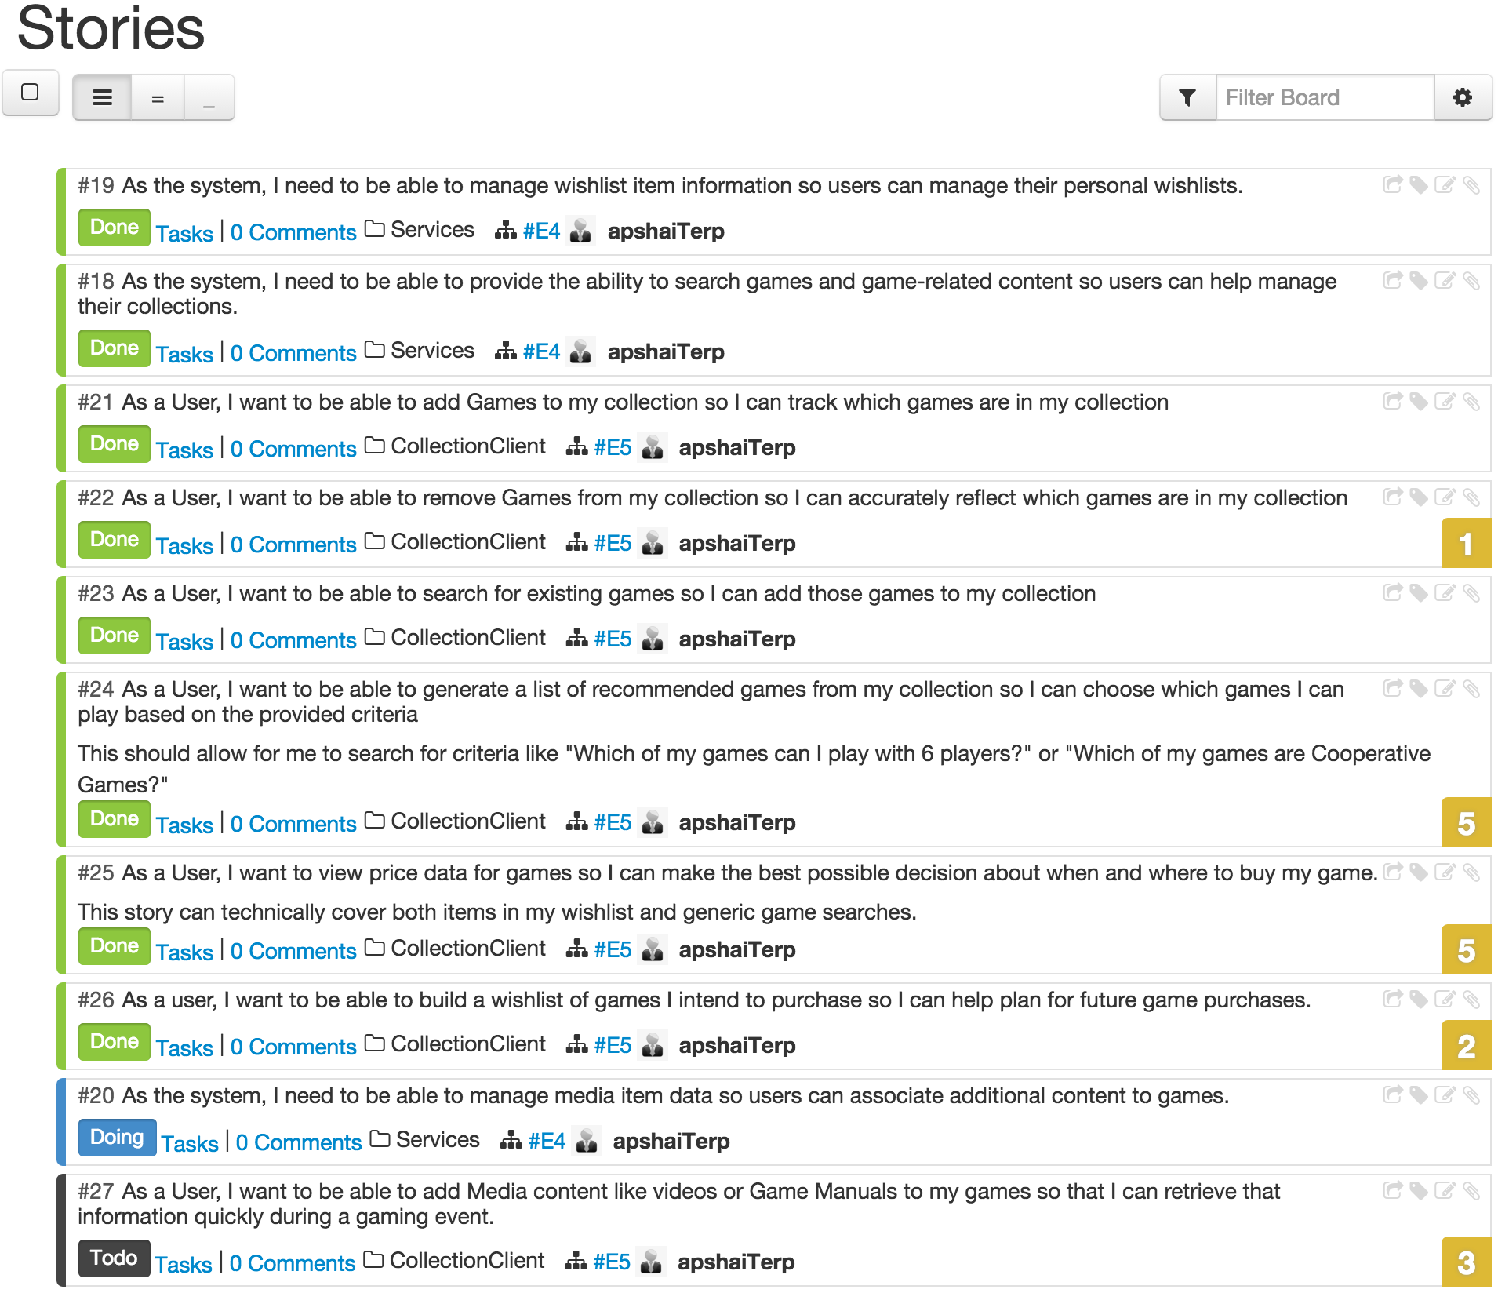

From a stories perspective, I was able to complete a decent number of stories this iteration, though in truth I probably could have split several of those stories into smaller tasks. I completed 8 stories, all focused on the collection user feature set. Of the initial key project features, I was able to complete all collection maintenance tasks, implemented the game wishlist, and the game recommendation tasks. Other important features such as Playthrough tracking, Media item association, and change notifications, were not implemented.

For the project as a whole, I completed 32 of 38 stories with 1 in flight and 5 not yet started.

1. **Implementation Details**

In previous iterations I used TLOC (Total Lines of Code) and MLOC (Meaningful Lines of Code) as a means of evaluating progress. While not a completely reliable metric for quality, I believe revisiting these statistics as the end of the project provides a useful means of illustrating where times was spent across the iterations. For instance, the jump in HTML code denoted in the growth of the TCM web-client is a good indicator for how much time was devoted to that component later in the project.

|  |  |  |  |
| --- | --- | --- | --- |
| **Project** | **Classes/Pages** | **TLOC** | **MLOC** |
| ac-games-pojos – Iteration 1 | 22 | 1777 | 1086 |
| ac-games-pojos – Iteration 2 | 38 | 2713 | 1568 |
| ac-games-pojos – Iteration 4 | 51 | 4263 | 2377 |
|  |  |  |  |
| ac-games-db – Iteration 1 | 3 | 54 | 39 |
| ac-games-db – Iteration 2 | 3 | 103 | 117 |
| ac-games-db – Iteration 4 | 3 | 154 | 179 |
|  |  |  |  |
| ac-games-db-mongo – Iteration 1 | 7 | 2841 | 2419 |
| ac-games-db-mongo – Iteration 2 | 13 | 3200 | 2753 |
| ac-games-db-mongo – Iteration 4 | 17 | 4844 | 4250 |
|  |  |  |  |
| ac-games-restservice-spring – Iteration 1 | 7 | 900 | 725 |
| ac-games-restservice-spring – Iteration 2 | 22 | 2927 | 2321 |
| ac-games-restservice-spring – Iteration 4 | 36 | 5176 | 4189 |
|  |  |  |  |
| ac-games-agent – Iteration 1 | 6 | 640 | 463 |
| ac-games-agent – Iteration 2 | 13 | 1718 | 1409 |
| ac-games-agent – Iteration 4 | 22 | 2850 | 2283 |
|  |  |  |  |
| TCM web-client – Iteration 2 | 5 | 785 | --- |
| TCM web-client – Iteration 4 | 19 | 7399 | --- |
|  |  |  |  |
| **Total Project Stats – Iteration 1** | **45** | **6212** | **4732** |
| **Total Project Stats – Iteration 2** | **94** | **11446** | **8168** |
| **Total Project Stats – Iteration 4** | **148** | **24686** | **13278** |

For the final report, I also wanted to layout all the REST endpoints and touch briefly on their configuration. I will not be explaining them all, as much of that has been done in previous reports and is covered by the initial project architecture and description, but I believe it will prove helpful to list out all endpoints and which messages they accept:

1. **/auto**

GET – Params [ source, value, userID ]

Sample Usage:

<http://107.188.249.238:8080/ac-games-restservice-spring-1.0/auto?source=game&value=full>

1. **/collection**

GET – Params [ collectionid, topx, compact ]

PUT – Params [ collectionid ]

Body [ Collection ]

POST – Body [ Collection ]

DELETE – Params [ collectionid ]

Sample Usage:

<http://107.188.249.238:8080/ac-games-restservice-spring-1.0/collection?collectionid=1&compact=y>

1. **/collection/add** (New During Iteration 4)

POST – Body [GameToCollectionData ]

1. **/collectionitem**

GET – Params [ itemid ]

PUT – Params [ itemid, collectionid ]

Body [UpdateItemEditables ]

POST – Body [ CollectionItem ]

DELETE – Params [ itemid, userid, cascade ]

Sample Usage:

<http://107.188.249.238:8080/ac-games-restservice-spring-1.0/collectionitem?itemid=6>

1. **/external/bggdata**

GET – Params [ bggid, name, review, source, batch, sync, filter ]

PUT – Params [ bggid, review, primarypub ]

Body [ BGGGame ]

POST – Body [ BGGGame ]

DELETE – Params [ bggid ]

Sample Usage:

<http://107.188.249.238:8080/ac-games-restservice-spring-1.0/external/bggdata?review=new&source=hybrid>

1. **/external/csidata**

GET – Params [ csiid, review, source, sync, filter ]

PUT – Params [ csiid, review, gameid ]

Body [ CoolStuffIncPriceData ]

POST – Body [CoolStuffIncPriceData ]

DELETE – Params [ csiid ]

Sample Usage:

<http://107.188.249.238:8080/ac-games-restservice-spring-1.0/external/csidata?csiid=138214&source=hybrid&sync=y>

1. **/external/mmdata**

GET – Params [ mmid, review, source, sync, filter ]

PUT – Params [ mmid, review, gameid ]

Body [ MiniatureMarketPriceData ]

POST – Body [MiniatureMarketPriceData]

DELETE – Params [ mmid ]

Sample Usage:

<http://107.188.249.238:8080/ac-games-restservice-spring-1.0/external/mmdata?mmid=41141&source=hybrid&sync=y>

1. **/game**

GET – Params [ gameid, batch ]

PUT – Params [ gameid ]

Body [ Game ]

POST – Body [ Game ]

DELETE – Params [ gameid ]

Sample Usage:

<http://107.188.249.238:8080/ac-games-restservice-spring-1.0/game?gameid=72293>

1. **/gamereltn**

GET – Params [ gameid, vendor ]

PUT – Params [ gameid ]

Body [ GameReltn ]

POST – Body [ GameReltn ]

DELETE – Params [ reltnid ]

Sample Usage:

<http://107.188.249.238:8080/ac-games-restservice-spring-1.0/gamereltn?gameid=74605&vendor=csi>

1. **/login**

PUT – Params [ userid ]

Body [ NewUserData ]

POST – Body [ LoginData ]

1. **/recommend** (New During Iteration 4)

GET – Params [ userid, mode, recnum ]

POST – Body [ RecommendValues ]

Sample Usage:

<http://107.188.249.238:8080/ac-games-restservice-spring-1.0/recommend?userid=1&mode=mechanics>

1. **/stats**

GET – Params [ type, userid ]

Sample Usage:

<http://107.188.249.238:8080/ac-games-restservice-spring-1.0/stats?type=user&userid=1>

1. **/user**

GET – Params [ userid, username ]

PUT – Params [ userid ]

Body [ User ]

POST – Body [ NewUserData ]

DELETE – Params [ userid ]

Sample Usage:

<http://107.188.249.238:8080/ac-games-restservice-spring-1.0/user?userid=1>

1. **/wishlist**

GET – Params [ userid, gameid, display, topx ]

POST – Body [ WishPost ]

DELETE – Params [ userid, gameid ]

Sample Usage:

<http://107.188.249.238:8080/ac-games-restservice-spring-1.0/wishlist?userid=1&display=compact&topx=5>

For reference, the code repositories for each project are listed below. All code for this release has been checked in to the Master branch of each project. Because class diagrams at this point are a little large to make inclusion in this document meaningful, they have been uploaded as part of the github project under the src/model folders.

* **ac-games-pojos** – <https://github.com/apshaiTerp/ac-games-pojos>
* **ac-games-db** – <https://github.com/apshaiTerp/ac-games-db>
* **ac-games-db-mongo** – <https://github.com/apshaiTerp/ac-games-db-mongo>
* **ac-games-restservice-spring** – <https://github.com/apshaiTerp/ac-games-restservice-spring>
* **ac-games-agent** – <https://github.com/apshaiTerp/ac-games-agent>
* **agent-site** – <https://github.com/apshaiTerp/agent-site>

Presented below are a few of the screen shots for work performed during Iteration 4. For a more complete overview of the work performed, please refer to the demo video (<http://youtu.be/jVqatAzhE_o>).

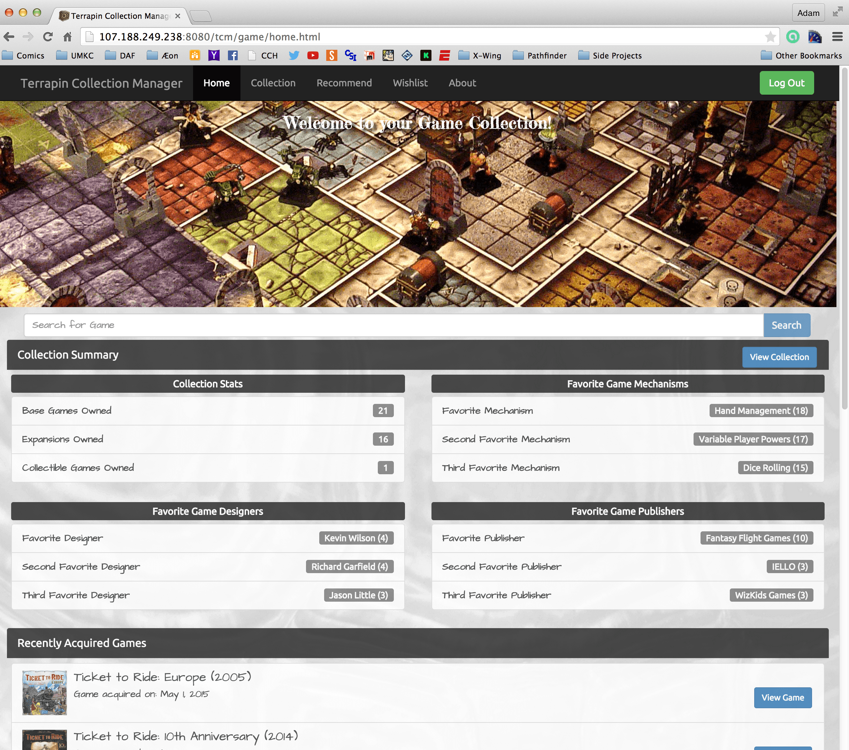





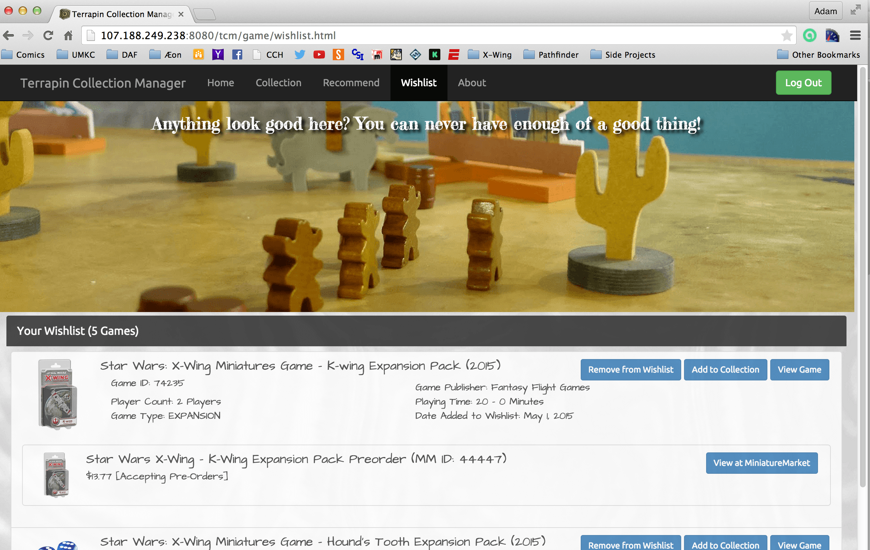

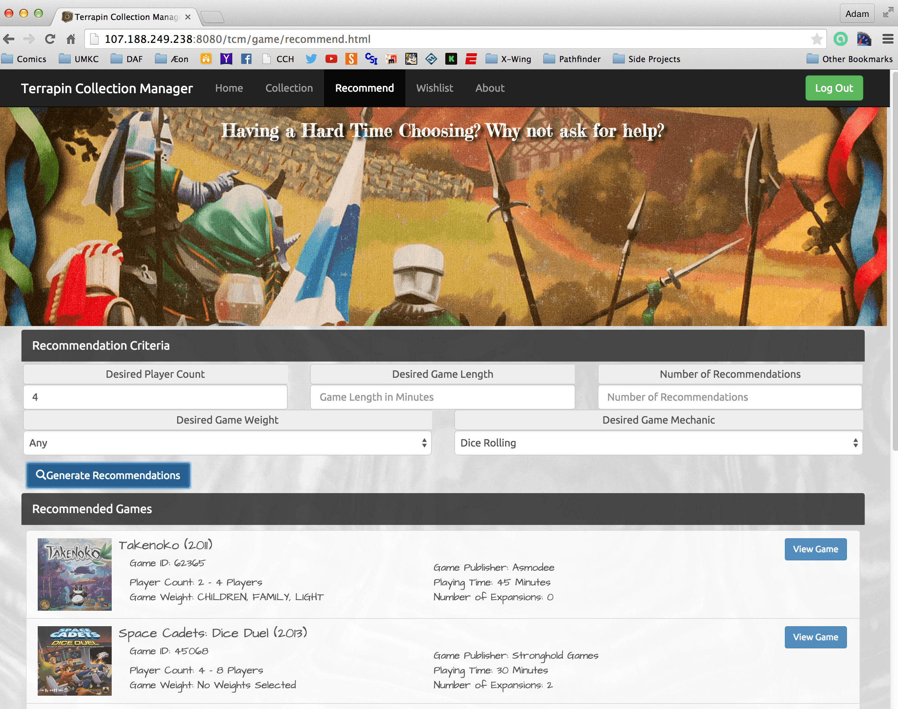

And now for some of the Mobile views of portions of the same page:

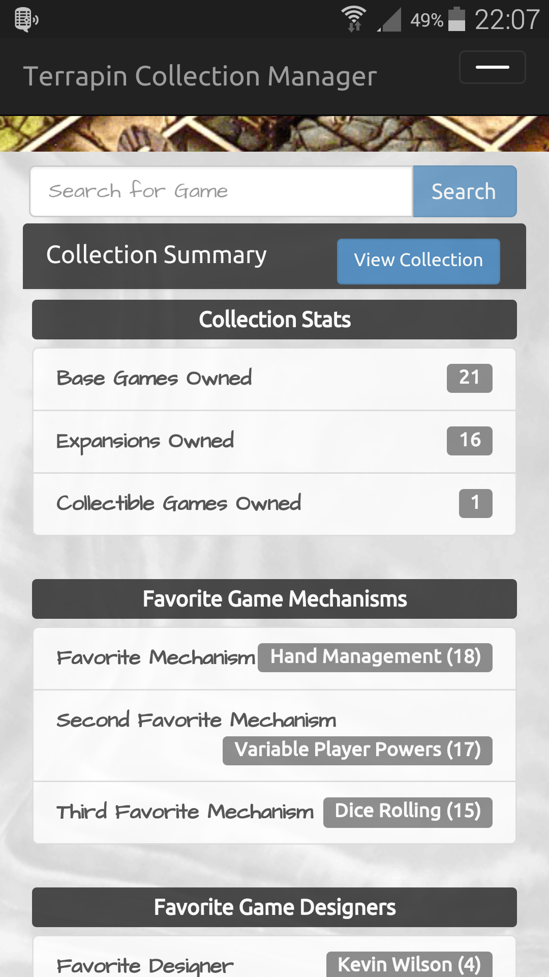 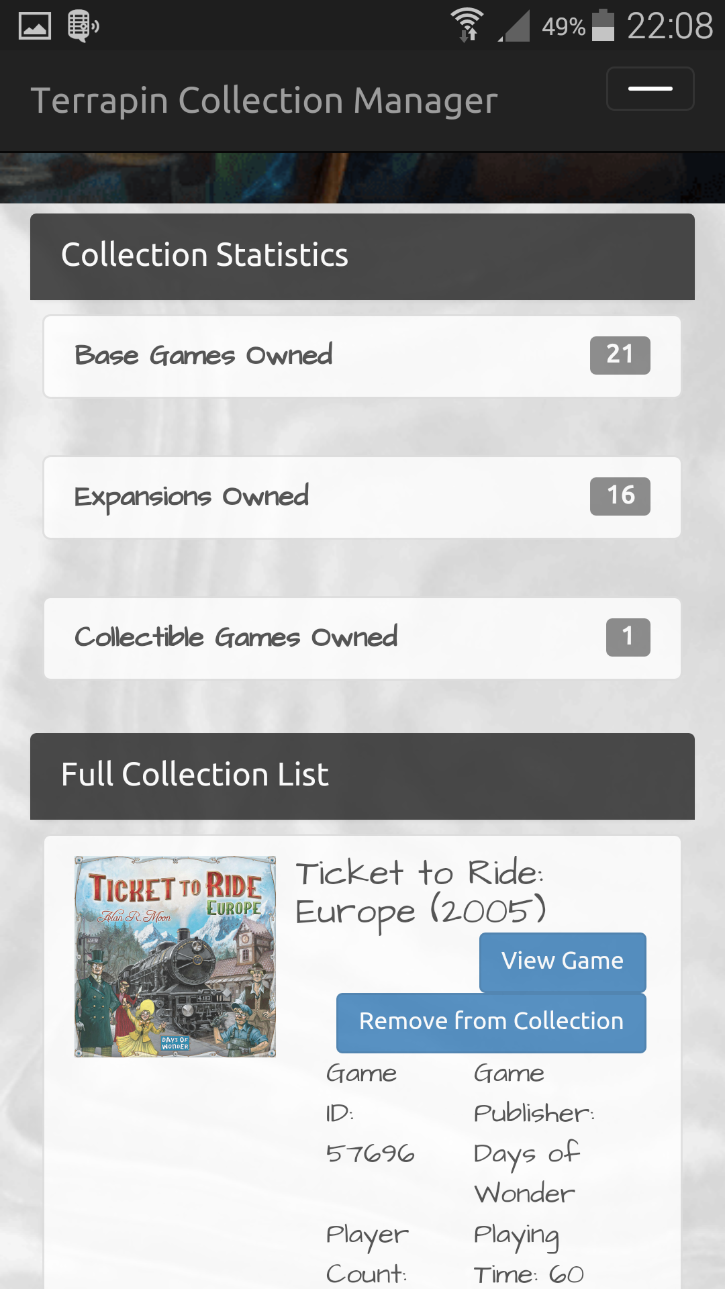

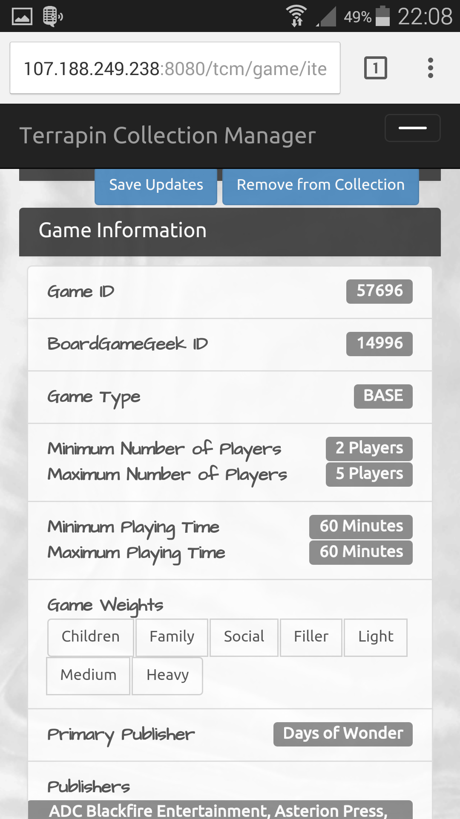 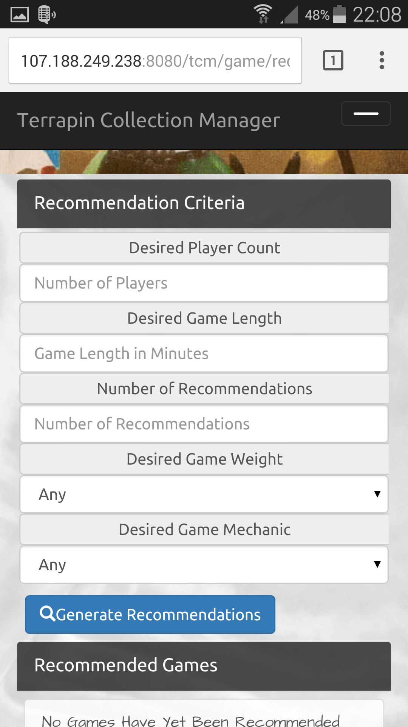

As the screen shots show, the layout is responsive, and the desired elements are being represented correctly in either traditional rich-client or mobile formats.

Presented below are also the Class Diagrams for each of the sub projects. Because the diagrams are rather large in for several projects, I am including the links here to view the source image, so that should the reader desire, they can view the diagrams in greater detail:

<https://github.com/apshaiTerp/ac-games-pojos/blob/master/src/models/allPojos.png>

<https://github.com/apshaiTerp/ac-games-db/blob/master/src/model/GamesDatabase.png>

<https://github.com/apshaiTerp/ac-games-db-mongo/blob/master/src/model/allMongo.png>

<https://github.com/apshaiTerp/ac-games-restservice-spring/blob/master/src/model/allRest.png>

<https://github.com/apshaiTerp/ac-games-agent/blob/master/src/model/allAgent.png>

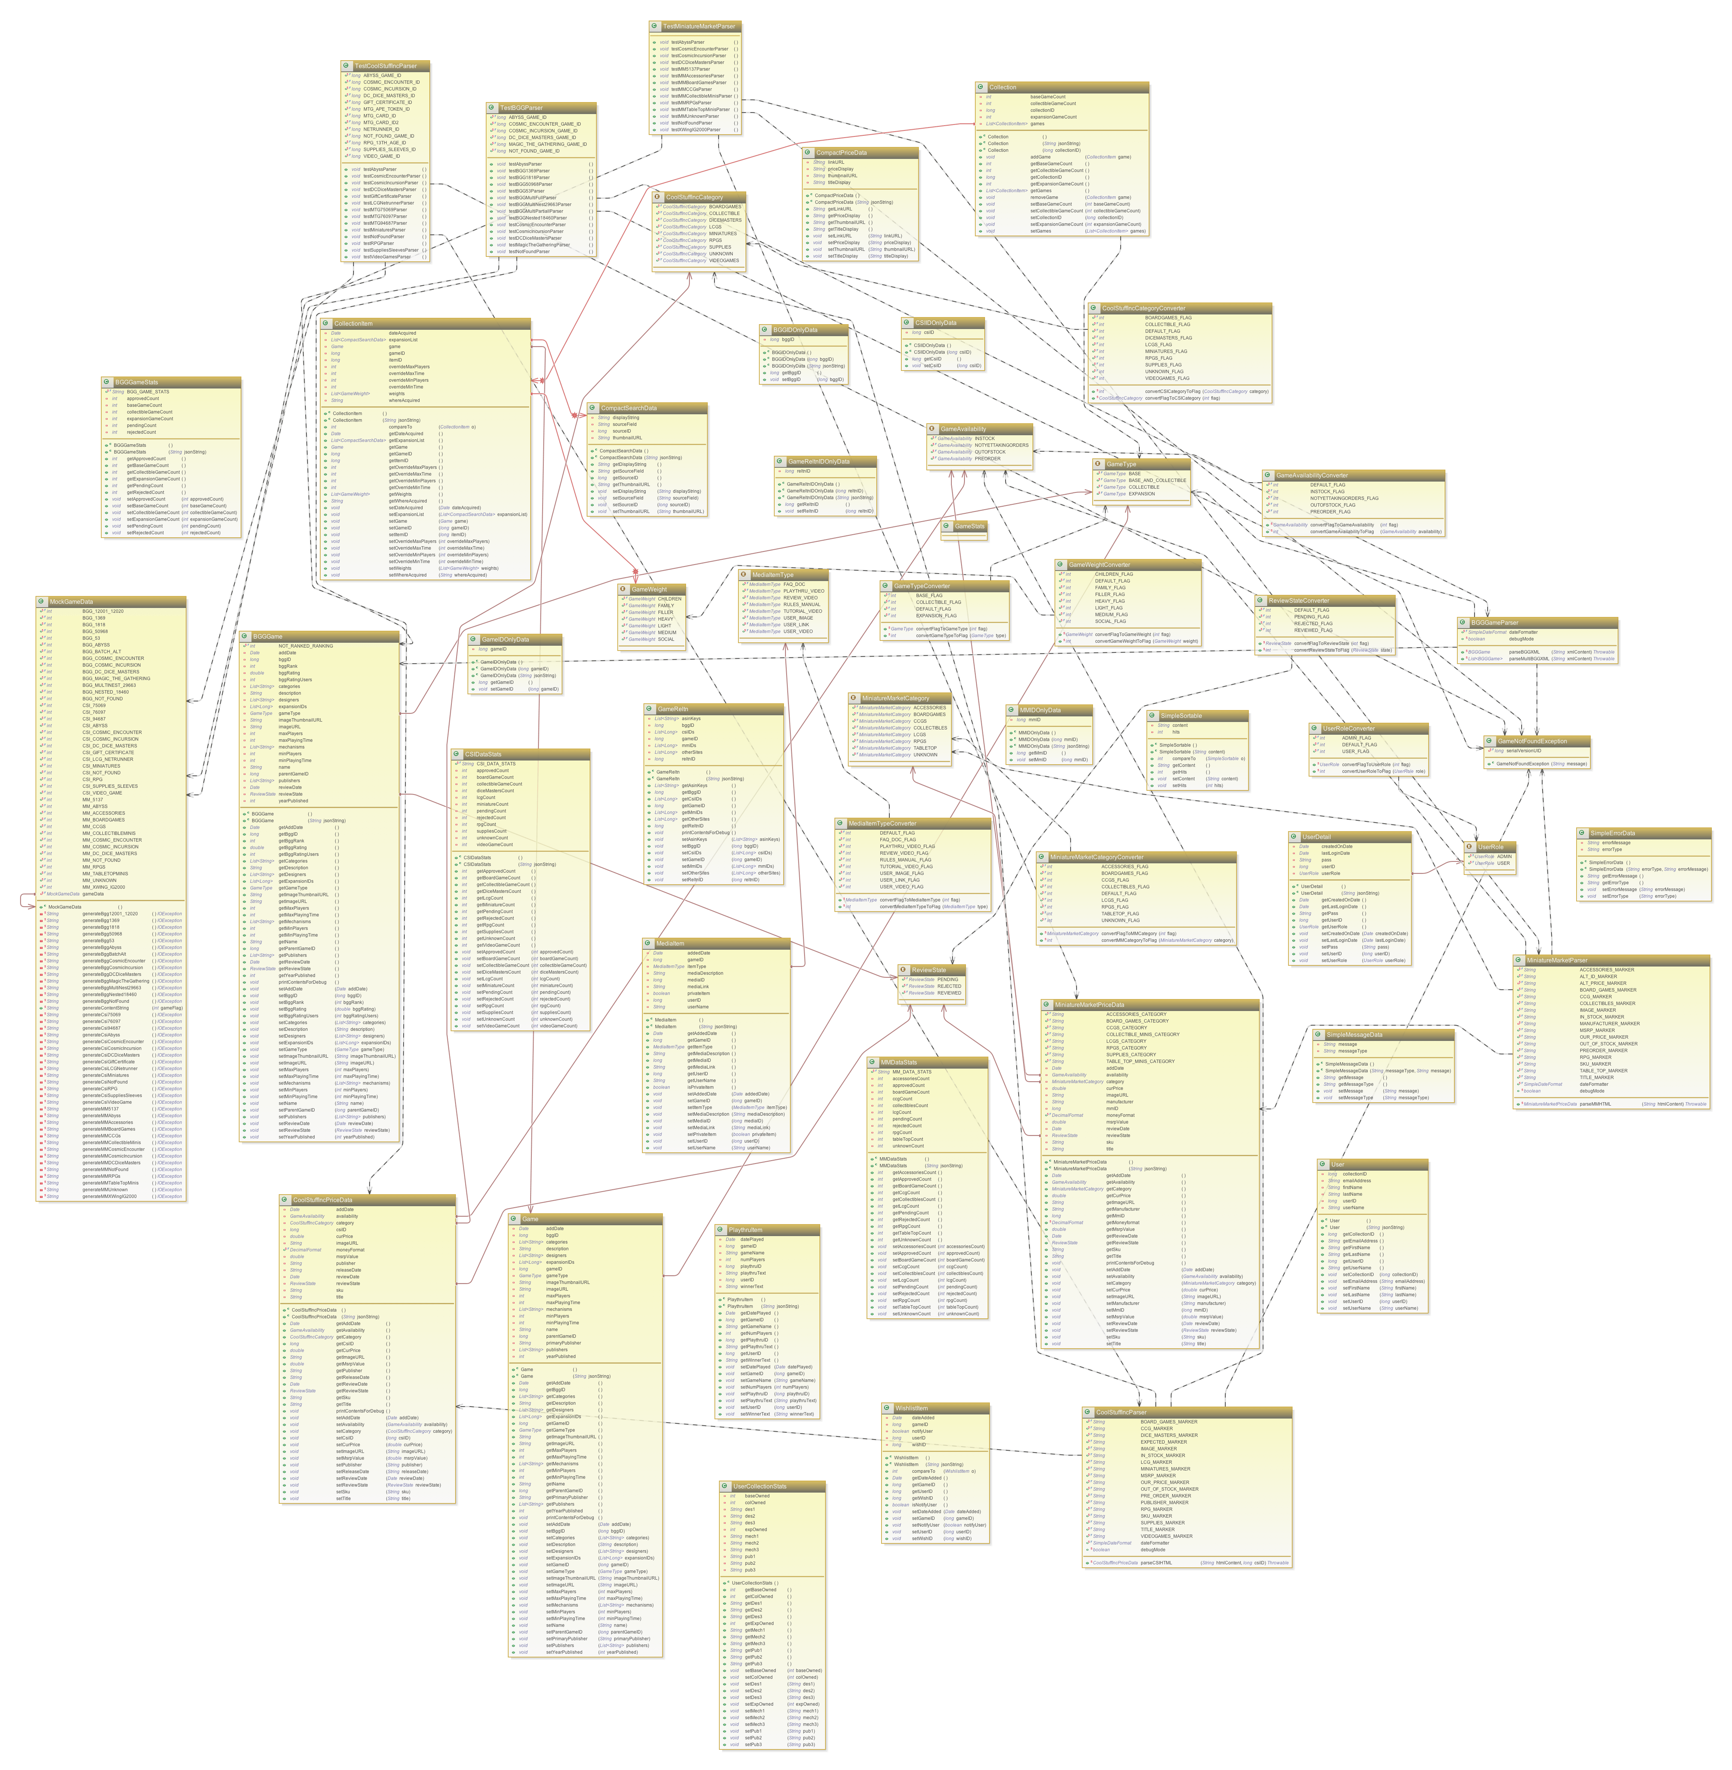

The ac-games-pojos Class Diagram

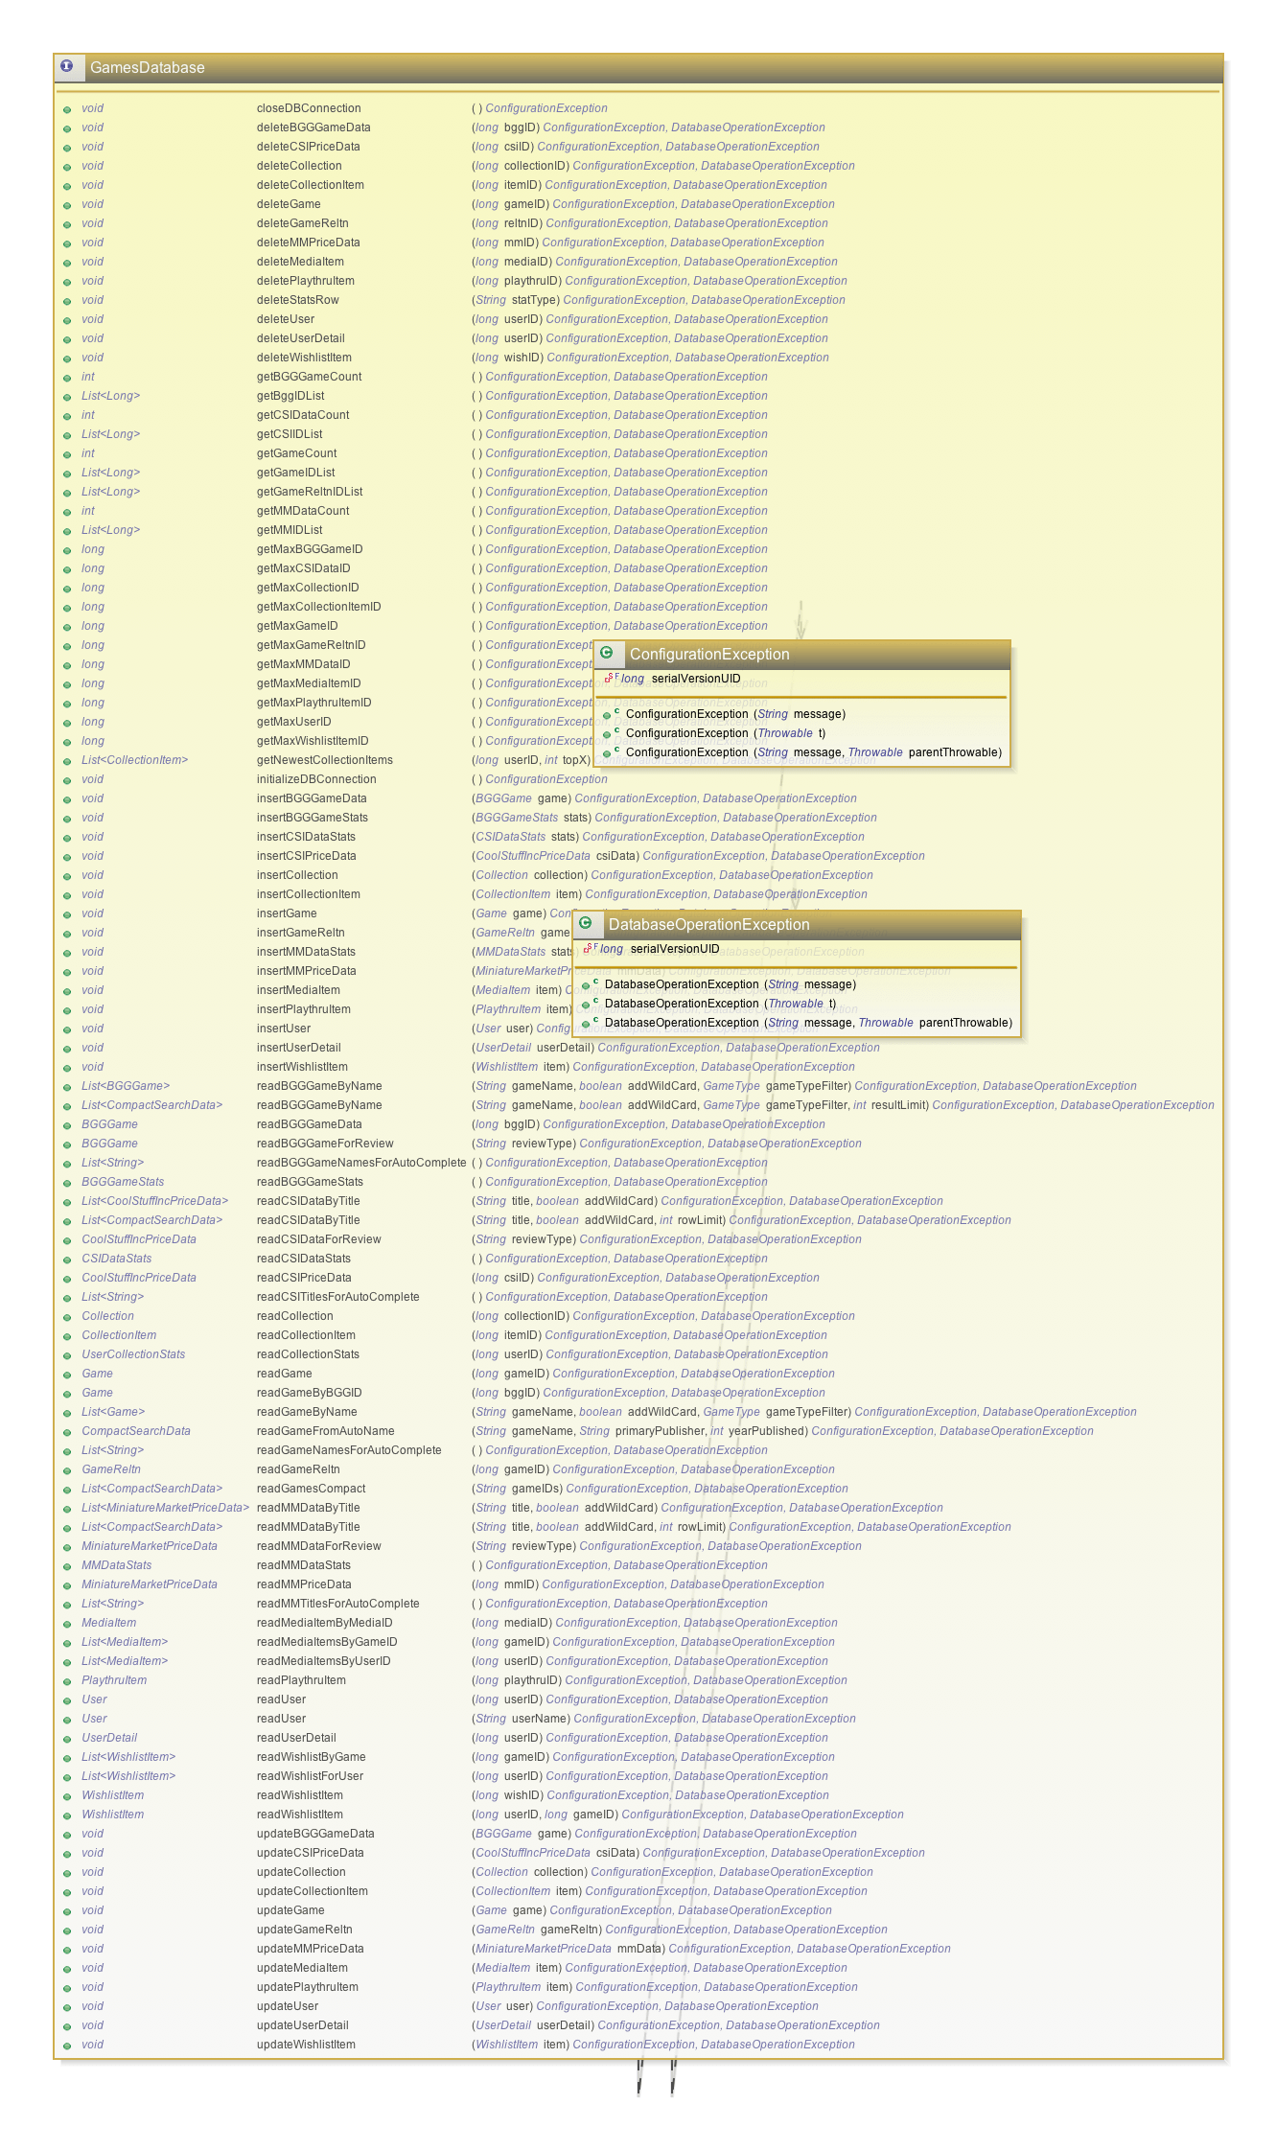

The ac-games-db Class Diagram

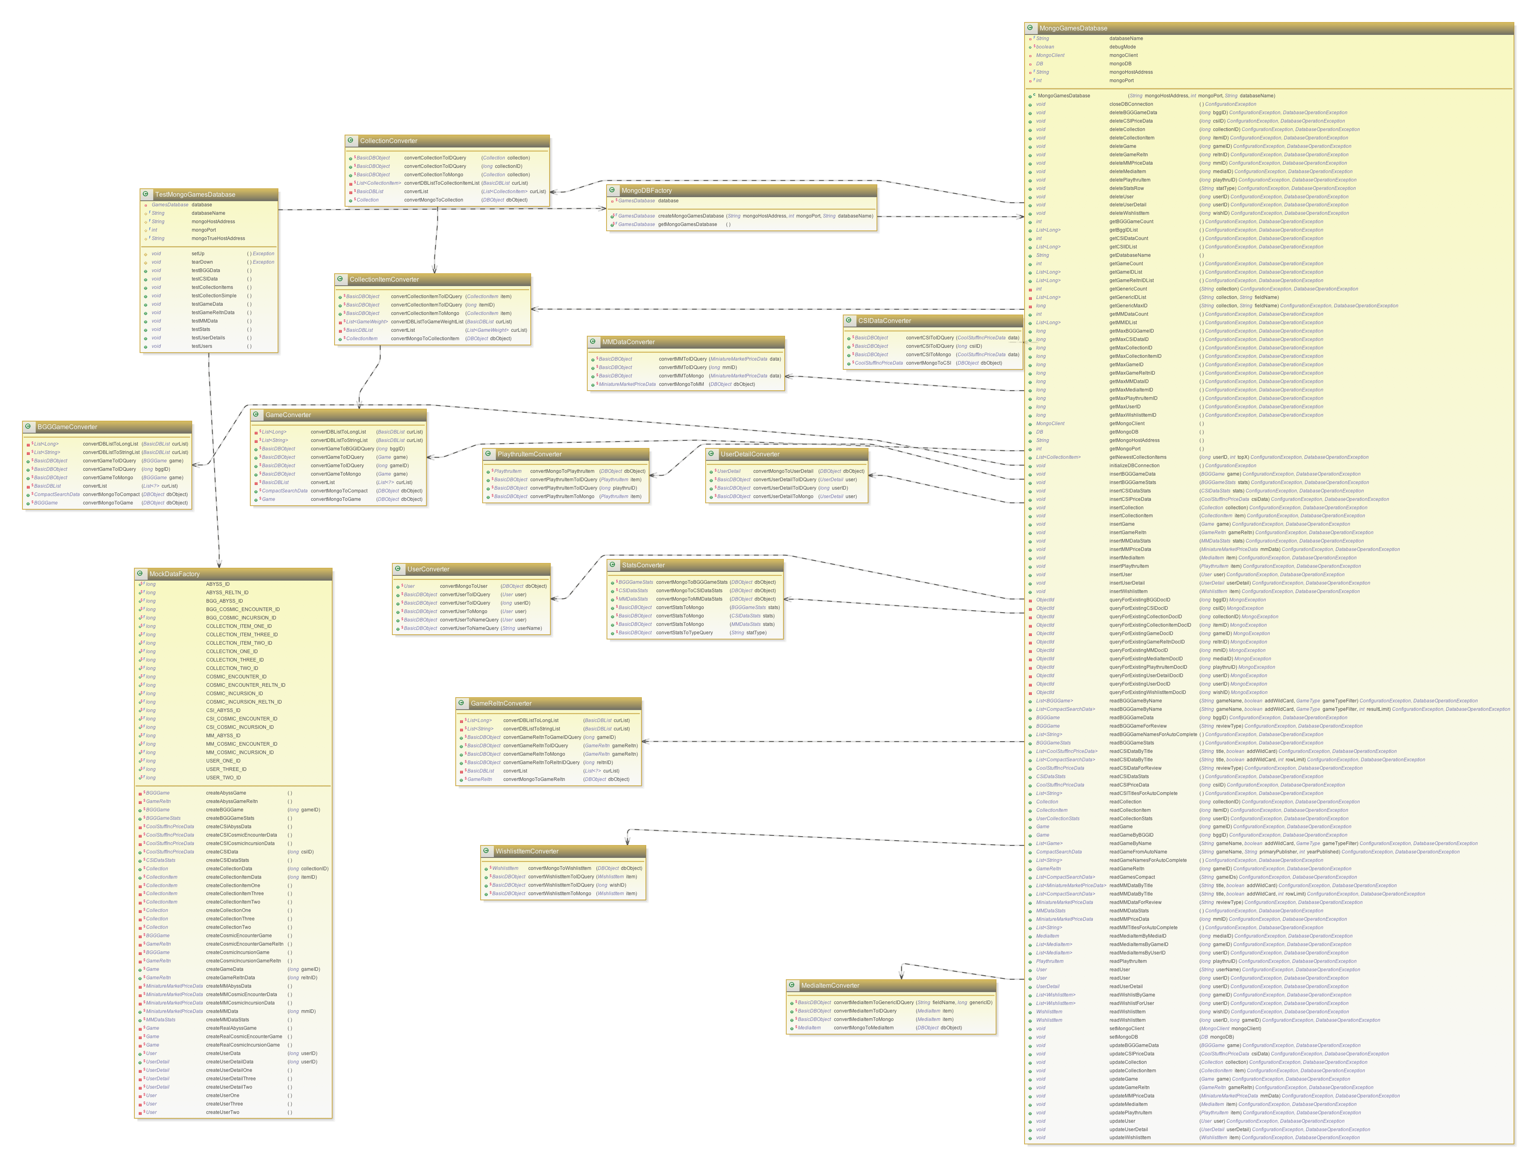

The ac-games-db-mongo Class Diagram

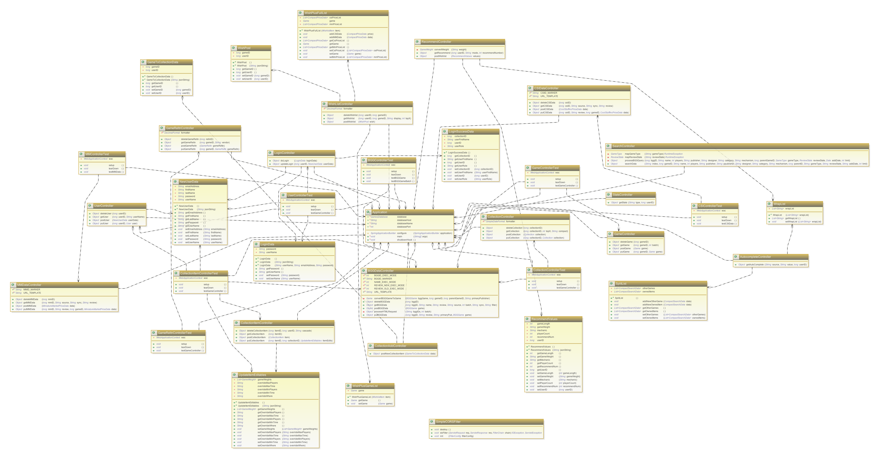

The ac-games-restservice-spring Class Diagram

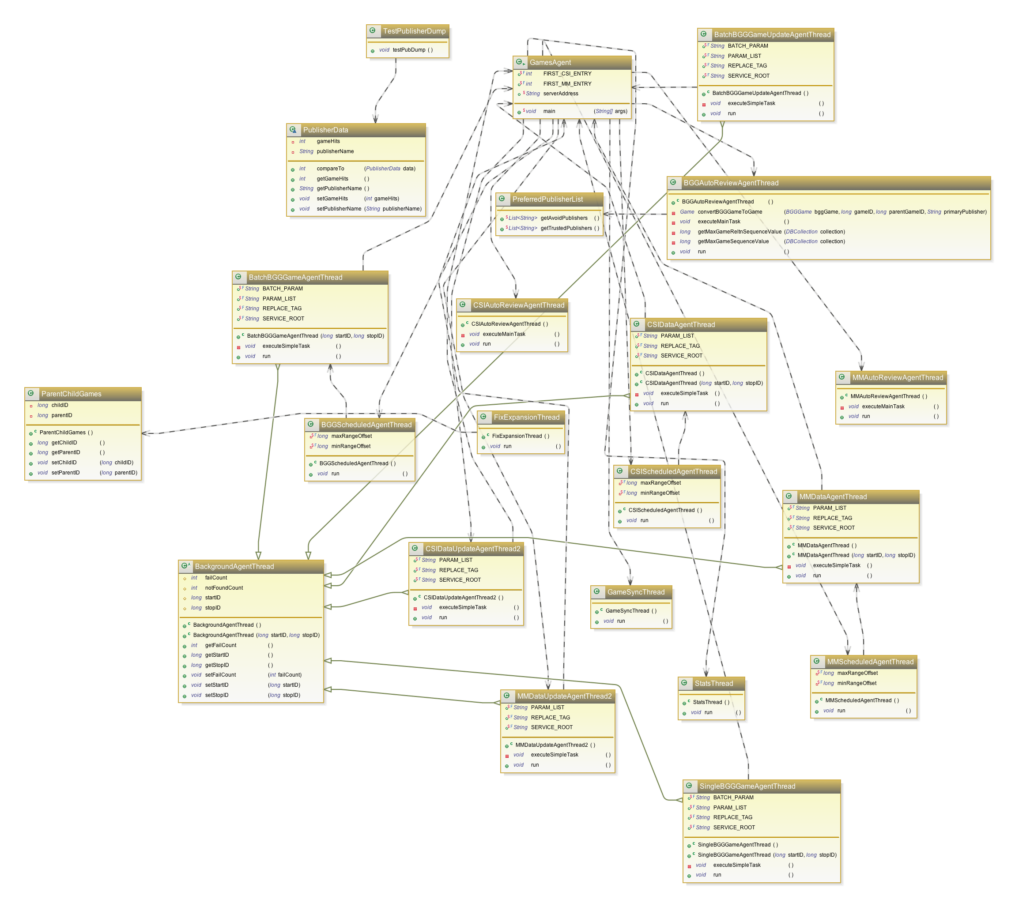

The ac-games-agent Class Diagram

1. **Testing**

Because the majority of the work during this iteration was focused on the front-end, testing was not expanded significantly during this iteration. I consider that to be a strength of the heavy commitment to test development in the previous two iterations.

While all test evidence is documented under the site data, for brevity’s sake I will only be including screen caps from the Surefire plugin report demonstrating the successfully execution of all test sets with this iteration end.

Complete Site Data can be found here:

* <https://github.com/apshaiTerp/cs-5551-documentation/blob/master/maven%20sites/ac-games-agent/ac-games-agent-1.0%20site/index.html>
* <https://github.com/apshaiTerp/cs-5551-documentation/blob/master/maven%20sites/ac-games-db/ac-games-db-1.0%20site/index.html>
* <https://github.com/apshaiTerp/cs-5551-documentation/blob/master/maven%20sites/ac-games-db-mongo/ac-games-db-mongo-1.0%20site/index.html>
* <https://github.com/apshaiTerp/cs-5551-documentation/blob/master/maven%20sites/ac-games-pojos/ac-games-pojos-1.0%20site/index.html>
* <https://github.com/apshaiTerp/cs-5551-documentation/blob/master/maven%20sites/ac-games-restservice-spring/ac-games-restservice-spring-1.0%20site/index.html>

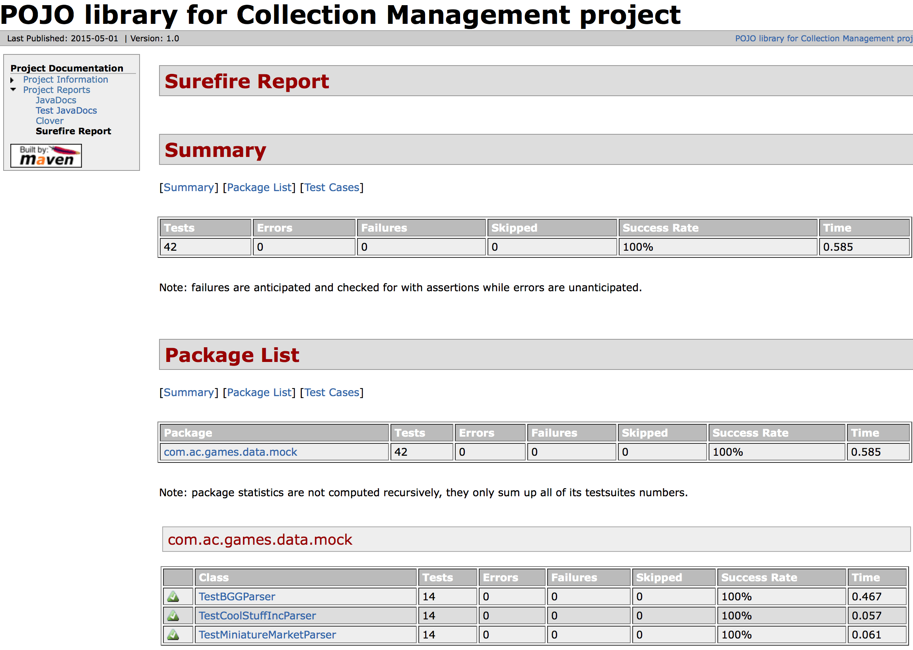

The ac-game-pojos Surefire Test Report

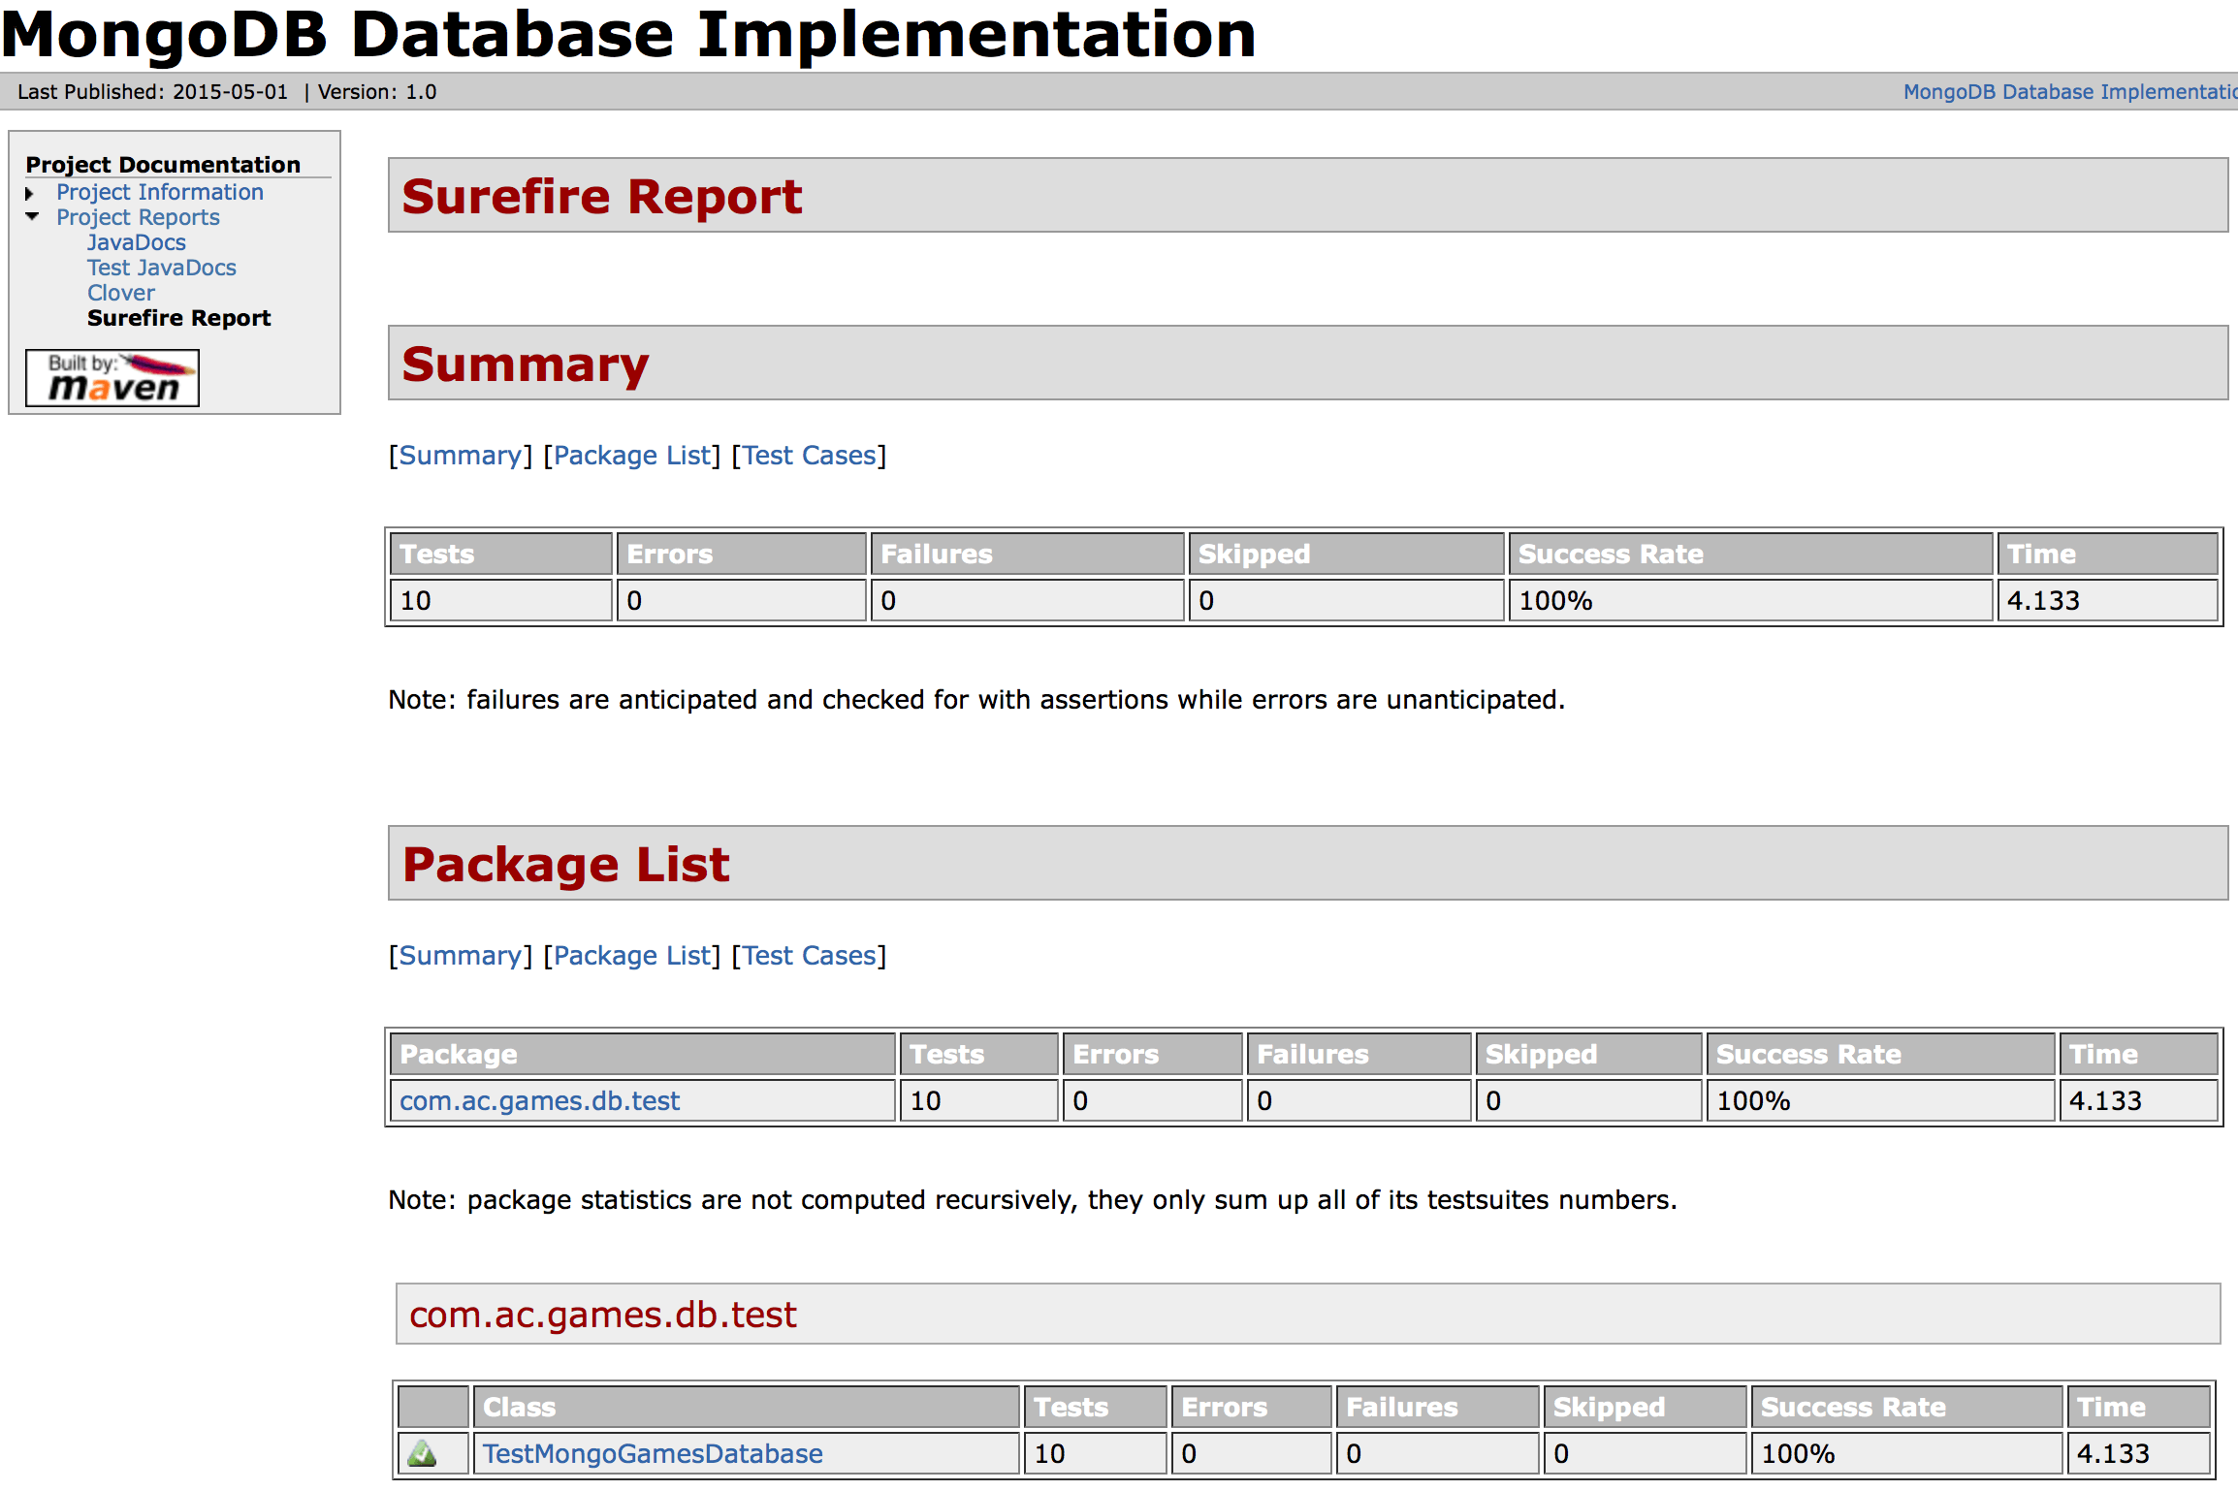

The ac-games-db-mongo Surefire Test Report

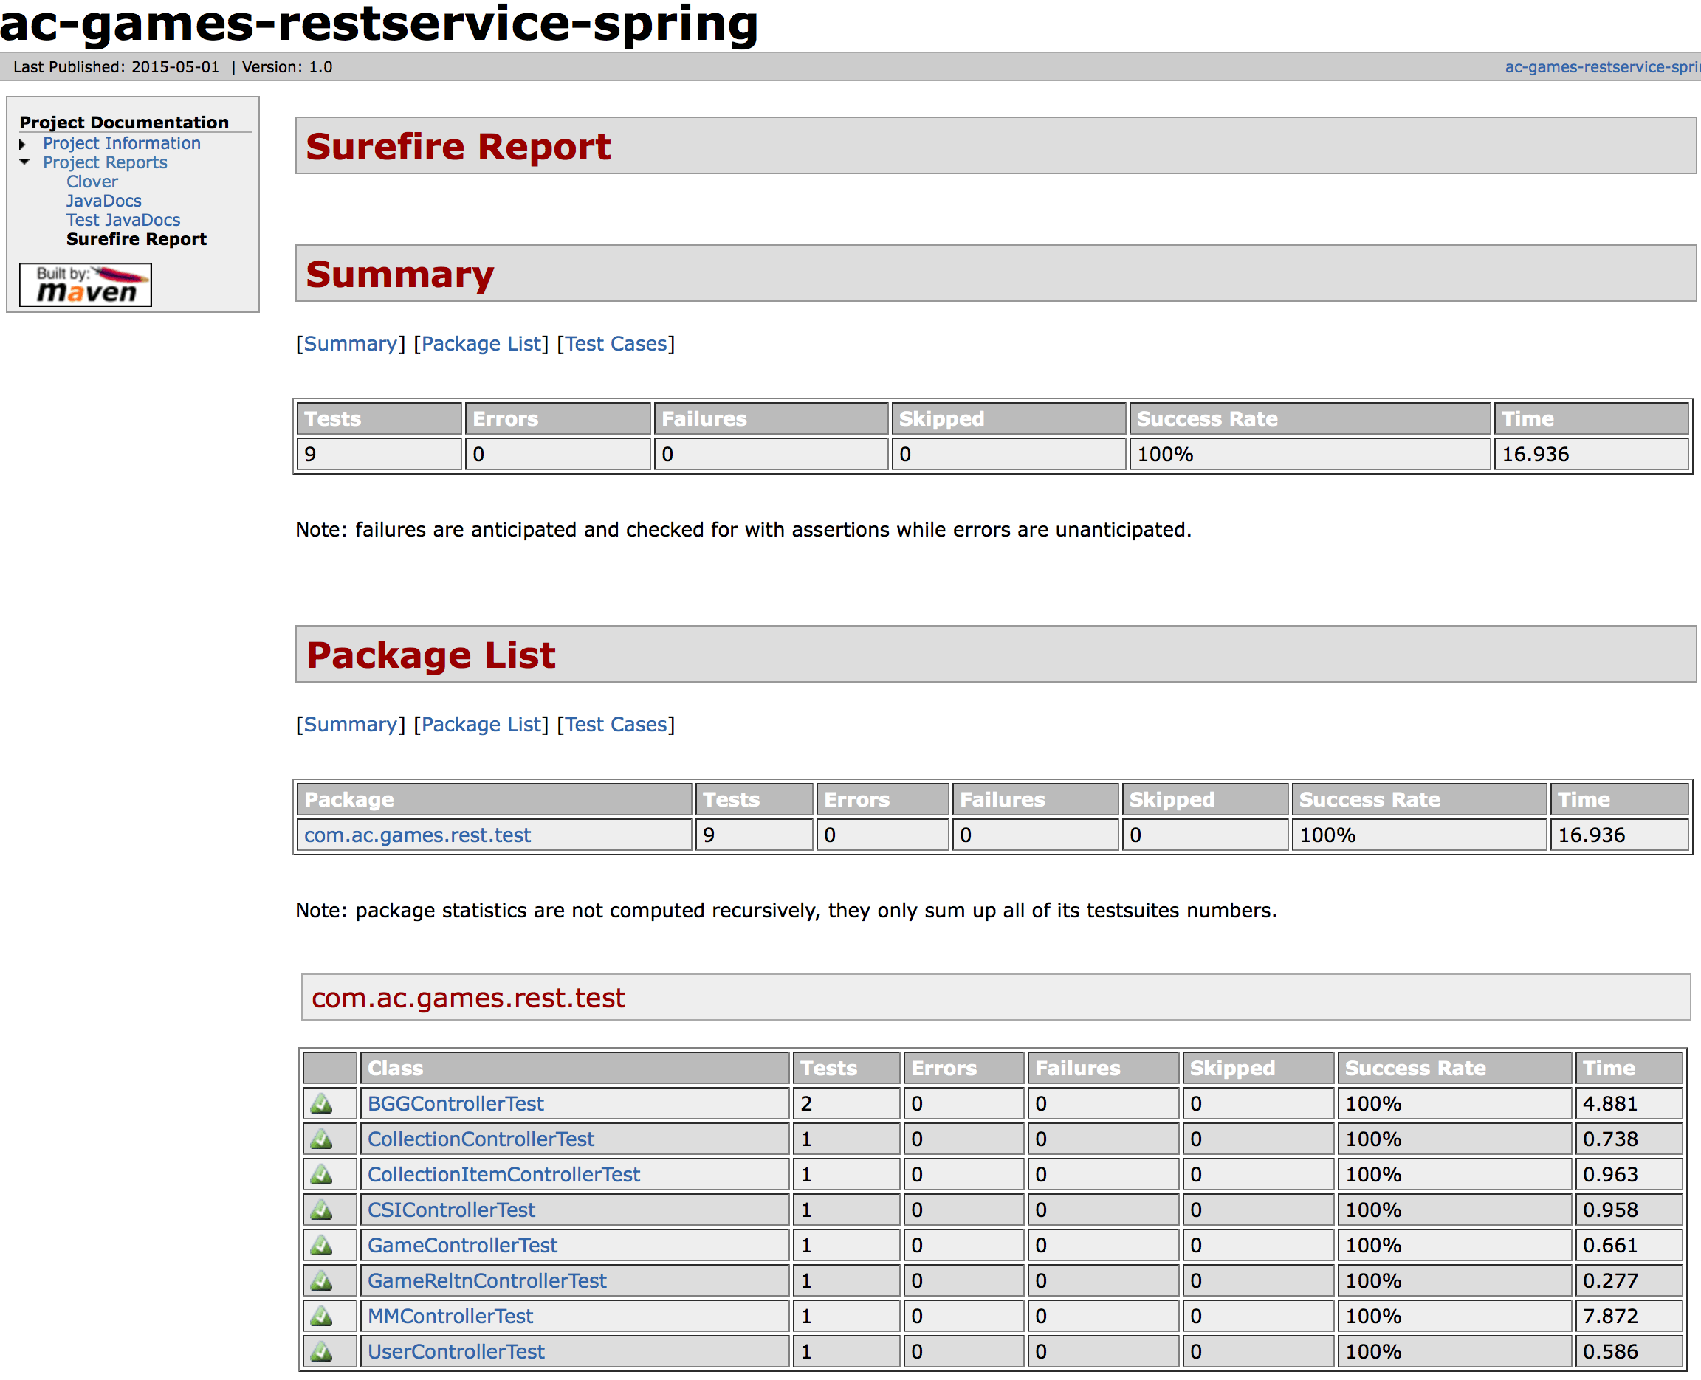

The ac-games-restservice-spring Surefire Test Report

For performance testing my web-client code, I decided to only use the YSlow analyzer this time around. Because most of my site is hidden behind an authentication wall, Google’s Load Time Analyzer could only really tell me about the non-authentication sites, in which very little work is being performed.

Overall, my grade percentage decreased some, now down to an overall average of 81 out of 100 for all pages in my system. Some of the changes could be easily made, such as switching to CDN references instead of relative CSS and javascript files, and some were brand new. Given that I expected to be doing more heavy lifting this iteration in terms of web requests and resources, I’m pleased to see the grade was as high as it was.

Included below are some sample screen caps from the performance tests:

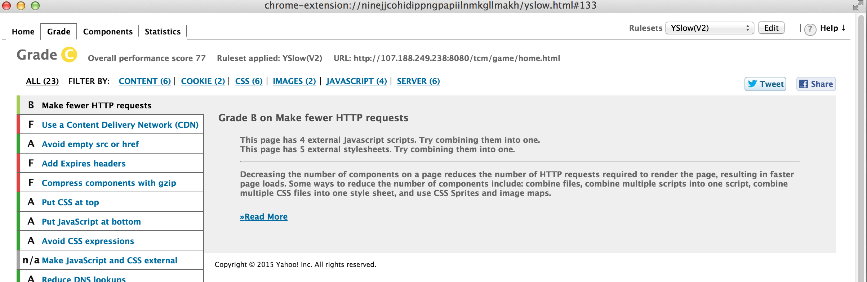

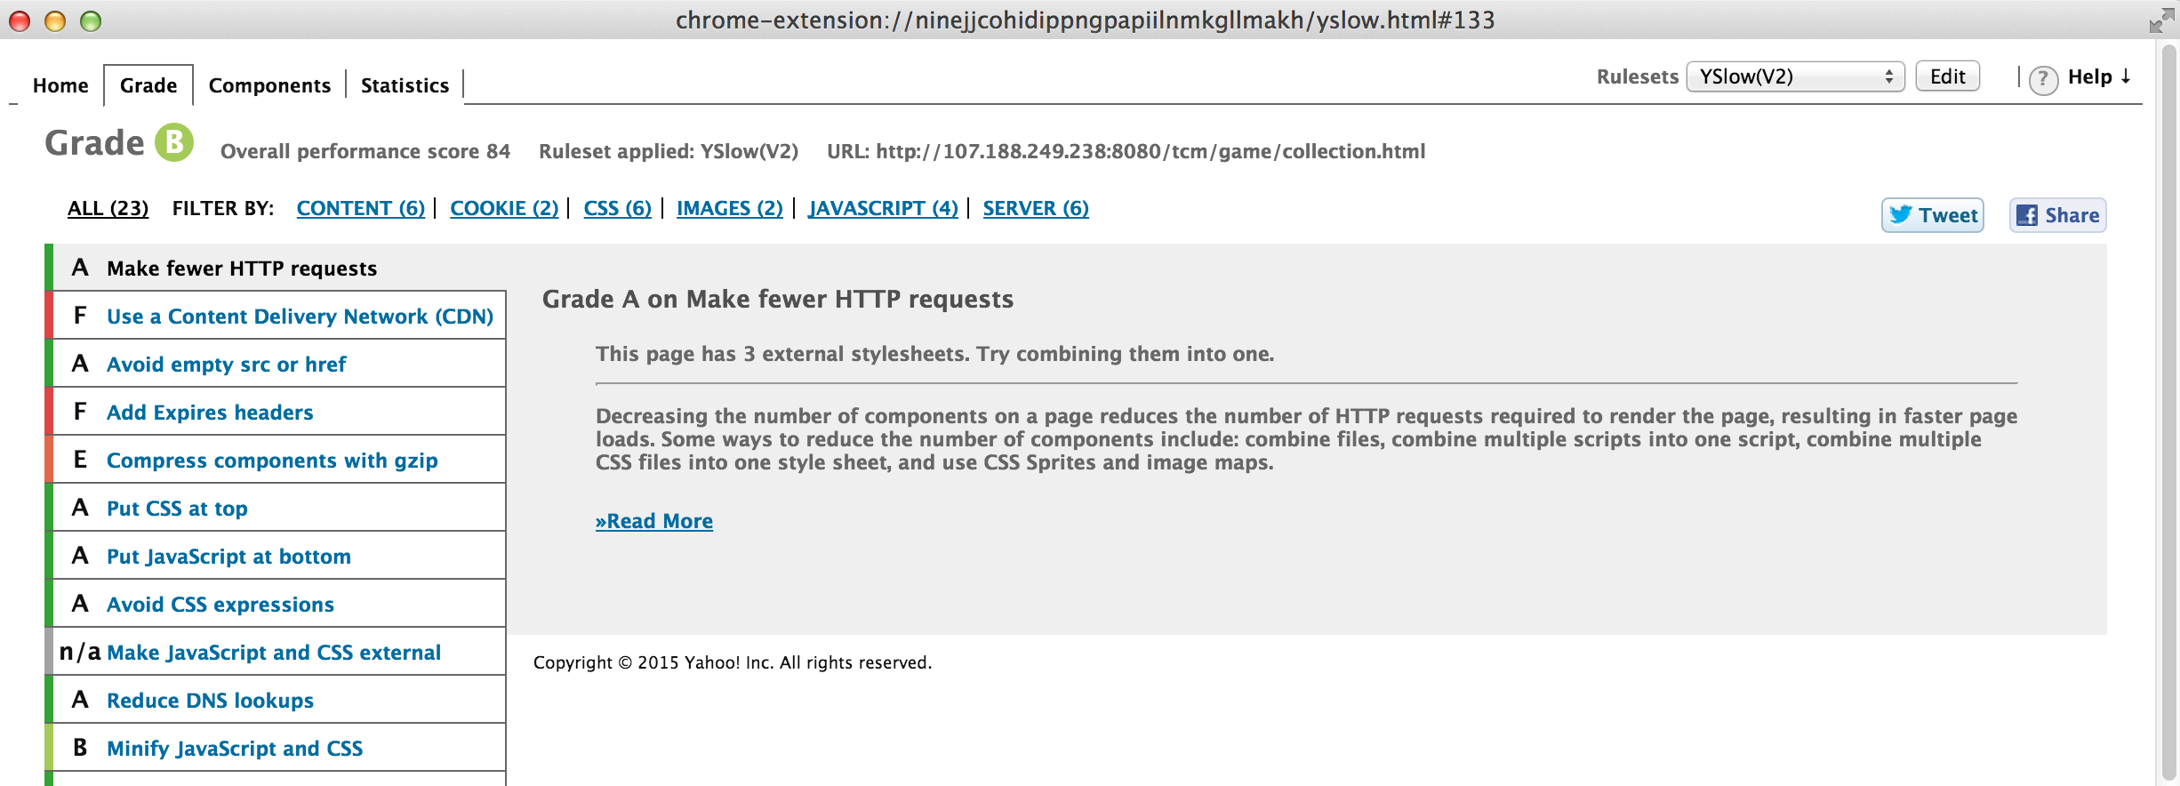

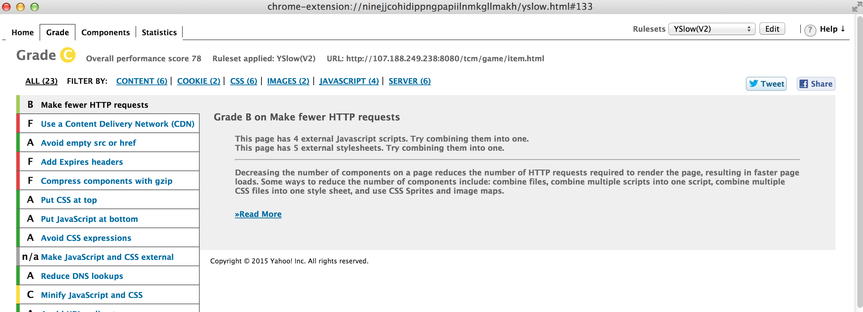

1. **Deployment**

The ScrumDo link to this iteration can be found here:

<https://www.scrumdo.com/projects/project/terrapin-collection-manager/iteration/121584>

The final end-states for my projects has been included in the GitHub documentation site, but this is the list of the final java project end-states:

**ac-games-pojos-1.0.jar**

**ac-games-db-1.0.jar**

**ac-games-db-mongo-1.0.jar**

**ac-games-restservice-spring-1.0.jar**

**ac-games-agent-1.0.jar**

The root URL for my service is <http://107.188.249.238:8080/ac-games-restservice-spring-1.0/>.

The URL for my site is <http://107.188.249.238:8080/tcm/>.

The Demo Video can be found at: <http://youtu.be/jVqatAzhE_o>.

All screen caps for the website generated above were taken using the live site deployment.

1. **Project Management**

Because I am a team of one, I can attest that all work completed on this project is my own. I have not made an effort to track the time spent on this project during this iteration, largely because of the issue discussed above between vacation and illness, but I feel that in spite of those issues, I have managed to accomplish a lot this iteration.

As mentioned, several stories were left incomplete during this iteration, but overall I am pleased with what I was able to accomplish and how it looks and performs. I plan to continue tinkering with this system so I can implement the remaining deficient features.

1. **References**

[1] – <https://github.com/apshaiTerp/cs-5551-documentation/blob/master/CS551-Project-Proposal.pdf>

[2]

<https://github.com/apshaiTerp/cs-5551-documentation/blob/master/CS%205551%20Project%20Plan.pdf>